Detecting illegal activities: the case of cartels

**Expected Cartel Behaviour***Formulas Extract for CFD model*

# Utilization rate of capacities

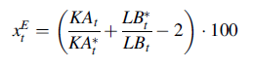

xEt - excess supply or demand

KAt - denotes the degree of capacity utilization

KA*t - the normal level of capacity utilization

LB*t - the planned inventory of finished goods

LBt - the inventoryof finished goods

LFt - the range of order backlogs

LFt - the customary range of order backlogs.

In competitive markets, price changes provoke an adjustment of excess demand or supply indicated by xEt ranging around the target value zero. In case of deviations from the null-axis caused by exogenous shocks, the price induces after a period of adjustment a recurrence of xEt to the null-axis.

 (1)

In case of cartels we expect a stationary time series with a negative long run mean. To test the existence of a long run mean of zero (or negative) we implement the Augmented Dickey–Fuller-Test.

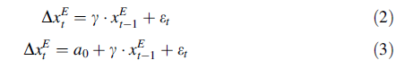

With the ADF-test it is possible to test the presence of a unit root with no intercept as a random walk model (see Eq. 2) and with intercept (Eq. 3). If we take a look at a generated first order process  with et generated from a white noise process, the et’s are uncorrelated random variables with expected mean zero.

xEt  has a unit root if a1 = 1. By taking the difference   it follows that holds . Testing the null hypothesis  leads to the same result as testing a1 = 1.

 describes the change of xEt between two periods. In Eqs. 2 and 3 the change of

xEt is dependent of the moment xEt-1 one period before. The parameter of interest inall the regressions is  series contains a unit root. The different cases are presented in the below table.

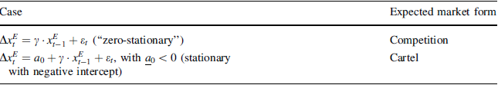

# Correlation between utilization rate of capacities and price changes

Regression  


*  - unbalanced price changes
* - nominal price changes

If the market is competitive, the correlation between unbalanced and nominal price changes  is positive (b1 > 0).

# Rate of return difference.

is defined as the difference between a rate of return representing all firms prevalent in the market under consideration (rUt) and a broader industry class comparison rate of return (rVt). Thus, the following holds:



Both values (rUt and rVt) can be found by using the following ratio:



*  denotes the annual operating profits before tax
*  the changes in Reserves
* **ZA** – the interest expenditures
* **ZE** the interest gains
*  other revenue streams,
* **WP** the securities
* **SA** other amortizations
* **SV** tangible assets
* **FV** receivable assets
* **BT** participation investments and akt
* **RAP** as active accounts receivable and Payable
* The numerator indicates pre-tax operating profits and the denominator annual average capital committed

Results  
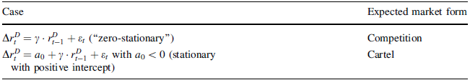

# Correlation between rate of return difference and capacity growth rate



* w - capacity growth rate
* K - production capacities in the observation market



 - the change in the capacity index

The base value should be established as a value lying in the middle of the observation values[1]

The correlation between rate of return difference and capacity growth rate

changes can be tested by:



If the market is competitive, the correlation between unbalanced  and

capacity growth rate  is positive 

**The next three criteria should only be tested** if the industry displays cartel-like behavior when looking at criteria 1-4.

# Distribution of nominal price changes

We employ the Kolmogorov–Smirnov test, which is a non-parametric (distribution-free) test comparing two distributions. In fact, the Kolmogorov–Smirnov D-statistic measures the distance between the empirical distribution functions of two samples.

The null hypothesis of the test states that both samples are drawn from the same distribution. Formally, the test statistic is defined as follows:



F0(x) and F1(x) - empirical cumulative distribution functions constructed for each of the two samples that are being compared.

When this supremum absolute difference exceeds a certain critical value, the null of two samples being drawn from the same distribution is rejected.

# Variance of capacity growth rate changes

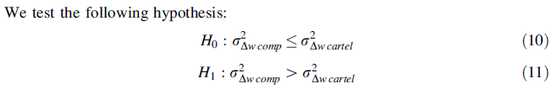

If H0 can be rejected, H1 will be true with a given probability. We used a significance level of 95 percent. Cartels reduce capacity utilization, rather than the capacities themselves. Since we are observing a capacity cartel, we expect a zero capacity growth rate. The variance in growth rate changes is significantly lower than for a competitive benchmark

# Innovation and Cost efficiency



* W - labour compensation
* L – labour input
* Y – output

The indicator can be interpreted as ratio of labor compensation per worker (W/L) and labor productivity (Y/L). In the cartel phase we expect a wage ratio that declines less strongly in comparison to competition

An adequate indicator for the determination of the wage ratio which declines less strongly in the case of a cartel is the quotient of labour compensation (W) and Gross value added (Y) at current basic prices.



Thereby it is tested if, concerning the development of the wage ratio, a structural interruption exists between the phase of competition and of a cartel

1. For more information see Nagel, F. (1998). Der Renditenormalisierungsprozeß, Ko¨ln.